PURCHASING A BOOK FROM AMAZON

Sign up
- Click the icon that says Google Chrome/Mozilla Firefox on your desktop.
- In the browser address bar, enter amazon.in using your keyboard and click Enter.
- Since you are a new user you need to Sign up. Click the Start here link located below
the Sign in button.
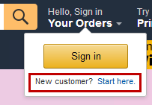
- In the following page, fill the below-mentioned fields and click Continue.
  - Your name
  - Mobile Number
  - Password
- A message will be sent to your mobile number with a unique code that needs to be entered in the text box given. In case, you did not receive any message, click Resend OTP.
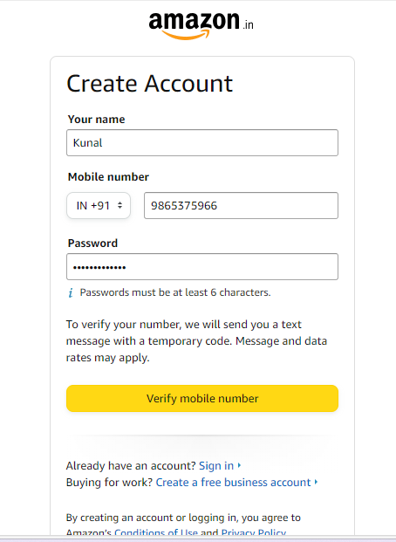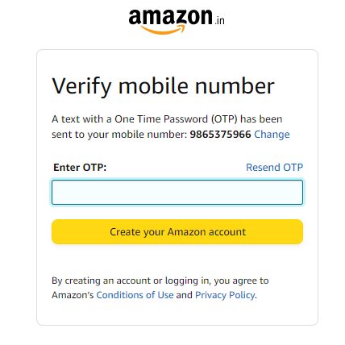
- Click the Create your Amazon account button. Your Amazon account is created. You will be re-directed to the home page. The page displays all kinds of items available on the website.

Searching for the Item
- Click the icon or press Enter on your keyboard to type name of the book for purchase, for example Ayn Rand The Fountainhead. Also, note that the software provides you suggestions as you type. Click on the item that matches your search query.
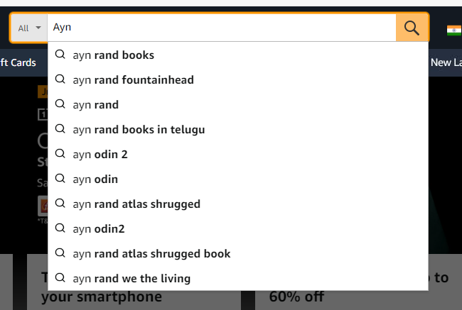
- Alternatively, click the Hamburger icon beside All (as shown in above screenshot) to view items categorized by type. Also, you can click the drop down beside the search bar to view the item categories.
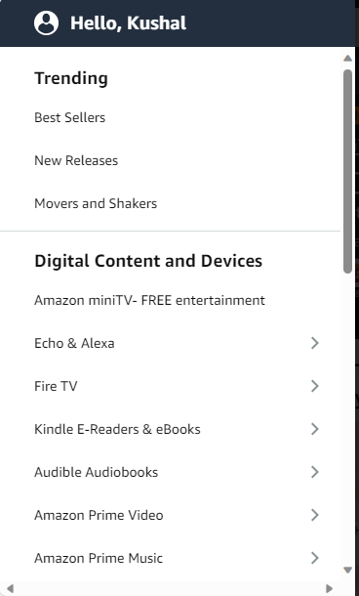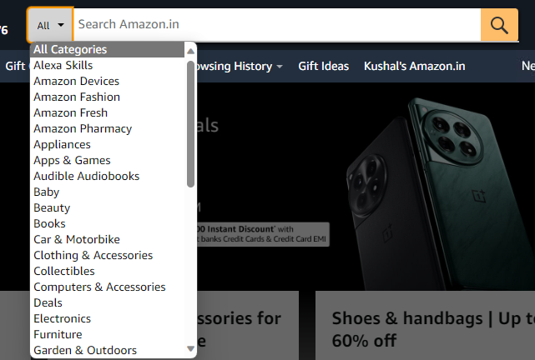

Purchase Process
- Once you select the book you want to purchase. Check the reviews of the book to gauge its quality. Better the star rating, better the quality.
- Decide on the type of book you want to purchase, there are options like Kindle (an e-reader), paperback, audiobook, hardcover etc., the cost for each is also mentioned.
- Click the Read sample link to have a preview of the book. You can view and read a few pages of the book. Alternatively, click the Audible sample button to listen to an audio sample of the book.
- Check for the addons like Free Delivery, Replacement/Return Policy, Secure Transaction, Pay on Delivery, and Amazon Delivered. Make sure you check the replacement/return timeline.
- Check for discount options.
- You can compare the prices from multiple sellers by clicking the link Other Used and New from.
- Check for the Delivery date and conditions for Free Delivery.
- Once you are sure about the purchase, select the number of books needed by choosing a number from the drop-down and click Buy Now. Check Add gift options for gift wrap this book.
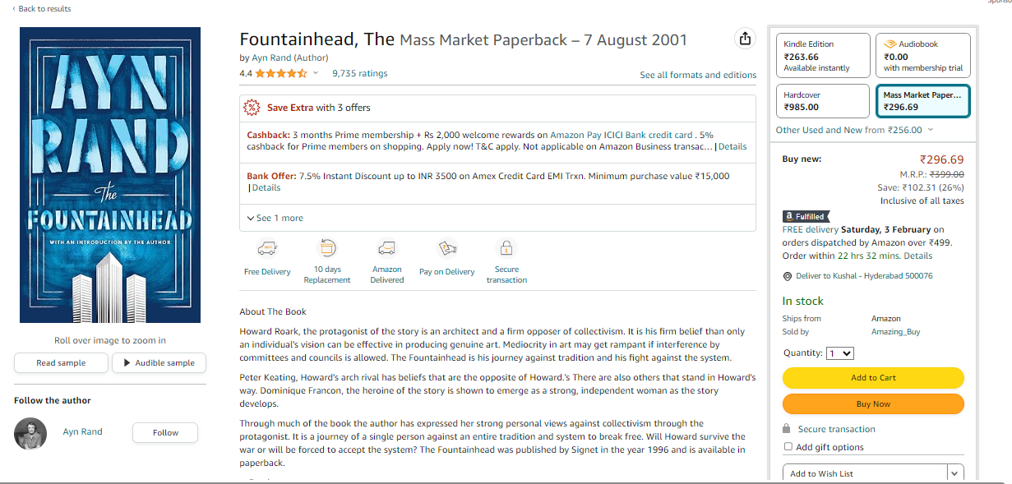
- You will be redirected to the Checkout page. Enter the address of the location where you need the book to be delivered. Alternatively, you can also pick up the parcel at a location near you.
- If you don’t have an pre-existing address, add a new one by clicking Add a new Address option. Fill in the details and click Use this address.
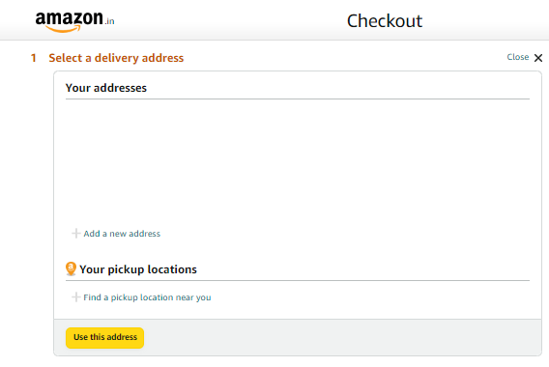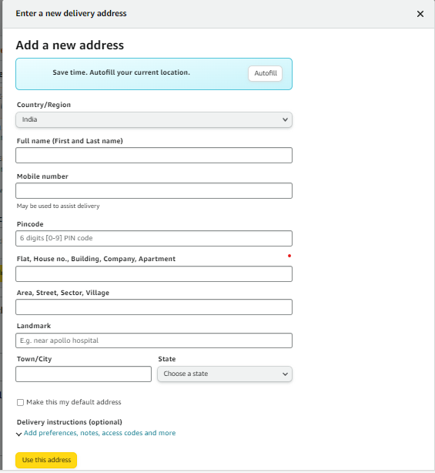
- Choose the payment options and click Use this payment method.
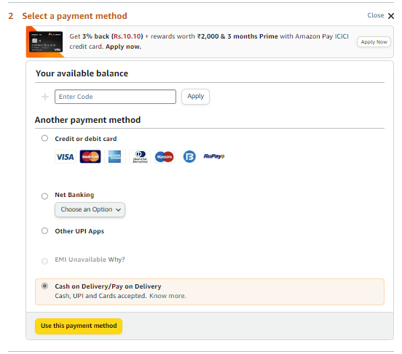
- You will be able to view your Delivery Address, Payment method, applied Offers, and Review items and delivery with relevant delivery information. Review it once and click Place your order.
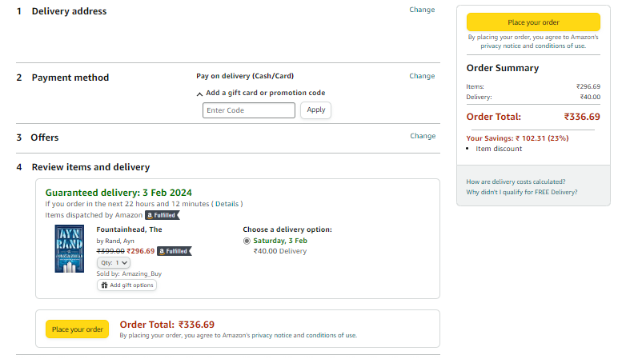
- The order will be placed, and a confirmation message will be displayed. Also, you will be receiving a confirmation message to your mobile.

